Week 1-2:
Getting Started with Renzulli Learning

Assignment  #1 | Profiler | - Login to http://www.renzullilearning.com  - Take the Profiler Assessment of your Interests, Learning Styles,  and Expression Styles  - Read Your Results
Assignment  #2 | Journal of Profiler Results | - Login to http://www.renzullilearning.com  - Click on the Journal icon at the top of your window.  - Create a Journal entry on how you feel about your Profile Results.  Do you agree or disagree with what it says about you? Was there anything you were surprised to learn? Use details to support your thoughts.  - Click Save. I will be able to read and respond to your Journal.
Assignment  #3 | Explore  My Enrichment Activities | 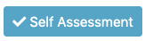  - Explore the My Enrichment Activities Section  - Select a category and one resource to complete a  Self-Assessment.  - Add any resources you really like to your Favorites.  - Rate a resource that you really like so other students  will be able to find it easily.
Assignment  #4 | Virtual  Field Trips | 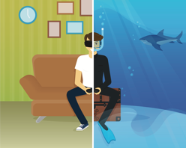  - Login to http://www.renzullilearning.com  - Go to My Enrichment Activities  - Choose Virtual Field Trips  - You might choose to narrow down to one Interest Area  using the drop-down menu  - View at least three Virtual Field Trips  - Click the Journal icon.  - Journal Entry: Which of the Virtual Field Trips that you explored would you like to visit in person? Explain why with at least 3 reasons and supporting details. Any advice for us if we go on this trip?
Notes from Your Teacher | Suggestions: video meet up times, office hours, additional resources  Please do not hesitate to contact me if you need assistance navigating the assignments.

